SPECIFICATION:

Screw: M3 x 8 Csk Torx (T10) M/S St Zi

Applicable standards:
DIN 965 or ISO 7046-1 (DIN EN ISO 7046-1)

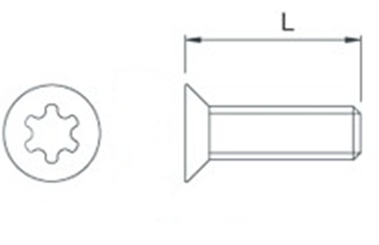
Screw size: | M3
Length, L: | 8mm
T-Drive | T10
Material: | Zinc-plated steel (Must be RoHS Compliant)

Note 1: Part /Component to be RoHS Compliant

